STEM HANDS-ON CHALLENGE KIT (SHOCK): DATE:__Nov 2025_____

Title: Make an electromagnet Course: 7/8th Physics Key Words: Magnetism, DC Power, Short Circuit,

Challenge: Build an electromagnet that can pick up the most paper clips from provided materials.
Objectives | Materials (per student)
Document the procedures for building your electromagnet so it can be reproduced by another team/student | Various Wire
Correct/Improve your methodology to increase the strength of your electromagnet. | Nails (payload) or paper clips
Explain to the class how you designed your electromagnet: what worked & didn’t work | 6/12 Volt batteries
 | Various cores

Procedures
Step by Step/Parameters | Questions/Variations
(Explain each step, guiding student’s learning, bringing closure, assessment, etc. Add more rows as needed) | (Anticipate & plan for possible student responses or behaviors.)
Investigate how to build an electromagnet on the internet | http://www.howstuffworks.com/electromagnet.htm
Using the materials provided, build an electromagnet that will pick up metal provided | Test your 6/12V battery with a multi-meter to make sure it is charged
Document your procedures (including failures) | Make sure you record how many wire wraps!
Record how many items you could pick up using just one 6/12V battery
Modify your design to increase the number of items picked up | What are the possible variables?
Answer the questions below
SAFETY PRECAUTIONS: Do not leave the power (battery or AC Power) attached to the circuit for extended periods of time due to the danger of overheating, fire and/or battery explosion. Wear safety googles/glasses while working with batteries.
Deliverables:
- Fill in the Blanks/Answers the following questions below:

An ______________________________ is a device that creates a magnetic field through application of electricity.

________________ charges attract, _______________________ charges repel.

Magnets are ferromagnetic, which means they work on _____________________________.
Draw and Label your simple electromagnet below

What are the three basic components of any electromagnet?
- _______________________________________________________

- _______________________________________________________

- _______________________________________________________
What is the relationship between number of turns of wire & the strength of the electromagnet?
_____________________________________________________________________________________________________________
__________________________________________________________________________________________________________
__________________________________________________________________________________________________________
Why is leaving the electromagnet connected dangerous? (Explain what happens to the ENERGY)
_______________________________________________________________________________________________________________
_______________________________________________________________________________________________________________
What materials make a good core? ______________________________________________________________________
What other uses besides picking up nails/metal is/could an electromagnet be used for?
______________________________________________________________________________________________________________
Draw the Electromagnetic Field Lines around the electromagnet below:

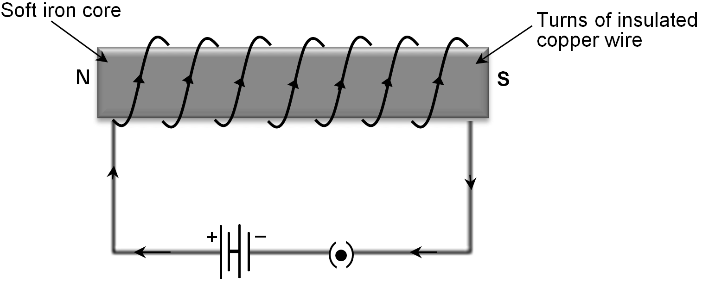
Name one way we make this challenge more fun/interesting/more difficult?

