Name:____________________________ Punnett Squares and Blood Types Nov 2025

- What is the Human Genome Project? ________________________________________________________
__________________________________________________________________________________________
HEREDITY
- Your dog is heterozygous dominant for Black Hair, Bb (B = Black Hair, b = blond hair). You breed the dog with a homozygous recessive blond dog of the same species (bb). Fill in the PUNNETT SQUARE below with the genotype possibilities for their offspring:

- What chance do you have that your puppies will be blond? __________________________________________

- You want to have all black puppies, what genotype should you mate your dog with? (REMEMBER, your dog is Bb.)

___________________________________________________________________

- What are the three types of dominance that might make this Punnett Square results incorrect?

- __________________________________

- __________________________________

- __________________________________
 | B | b
B
B
- Fill in the Punnett Square above to answer the questions:

- What is the chance that the dogs will have blond offspring? _____________________________

- If the mother is the top dog, what is her Phenotype? ___________________________________

- If the father is the side dog, what is his Phenotype? ____________________________________

- Using the pedigree key, answer the following questions:
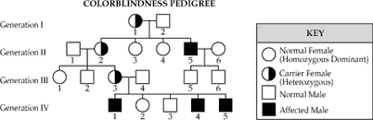

What percentage of male great-grandchildren will be colorblind? _______________________________
Based on the diagram, what % of male children of parents 5 & 6 will be colorblind? _________________
- Your Blood Type: _____________________
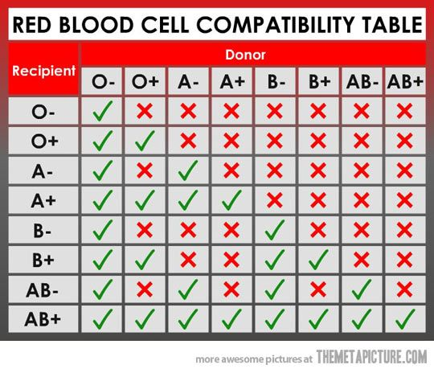
- Using the donor/recipient chart to the left, determine who you can donate blood to and who you can get blood from:

Who can you take blood from? ________________

__________________________________________

Who can you donate to your blood to?

Which blood do you think the Red Cross wants the most of? Why?

__________________________________________

